``Cash Flows and Accrual Accounting
Income statement are prepared on accrual basis, not on cash basis and income statement primarily reflects events related to the operating activity of a business which is the reason why net profit does not necessarily increases the cash position of a company. It must be noted that a profitable year does not necessarily increases a company’s cash position nor does a company with an unprofitable year always experiences a decrease in cash.
Purpose of the statement of cash flows
The statement of cash flows is an important complement to the other major financial statements. The statement of cash flows reports the changes in cash over a period of time and most important, explains these changes. The statement of cash flow allows users to assess a company’s performance on a cash basis.
An example:
Consider the following discussion between the owner of Fox River Realty and the company accountant. After a successful first year in business in 1997, in which it earned a profit of Rs 1,00,000, the owner receives the income statement and Balance sheet at the end of second year as presented below: Fox River Realty
Income statement for the year ended December 31, 1998
Particulars | Amount
Revenues | 4,00,000
Depreciation expense | 50,000
All other expenses | 1,00,000
Total expenses | 1,50,000
Net Income | 2,50,000
Fox River Reality
Comparative Balance Sheets as on 31st December
Particulars | Amount(1998) | Amount(1997)
Cash | 50,000 | 1,50,000
Plant & Equipment | 6,00,000 | 3,50,000
Accumulated Depreciation | (1,50,000) | (1,00,000)
Total Assets | 5,00,000 | 4,00,000
Notes Payable | 1,00,000 | 1,50,000
Common Stock | 2,50,000 | 2,00,000
Retained Earnings | 1,50,000 | 50,000
Total equities | 5,00,000 | 4,00,000
Now, after looking at the statements the owner wonders where did the cash go? Accountant then explains the reason for decline in cash by preparing a Cash flow statement.

Fox River realty
Statement of cash flows for the year ended 31/12/1998
Particulars | Amount
Cash Provided (used) by operating activities:
Net Income | 250000
Add back: Depreciation expense | 50000
Net cash provided by operating activities | 300000
Cash provided (used) by investing activities:
Purchase of new plant and equipment | (250000)
Net cash used by investing activities | (250000)
Cash provided (used) by financing activities:
Additional investment by owner | 50000
Cash dividend paid to owner | (150000)
Repayment of notes payable to bank | (50000)
Net cash used by financing activities | (150000)
Net decrease in cash | (100000)
Cash balance at beginning of year | 150000
Cash balance at end of year | 50000

Cash and Cash equivalents:
According to accounting standards, certain items are recognized as being equivalent to cash and are combined with cash on the balance sheet and statement of cash flows. Commercial paper (short term notes issued by corporation), money market funds and treasury bills are example of cash equivalents. To be classified as a cash equivalent, an item must be readily convertible to a known amount of cash and have an original maturity to the investor of three months or less.
Classification of cash flows:
For the statement of cash flows, companies are required to classify activities into three categories: operating, investing and financing. Each of the three types of activities can result in both cash inflows and cash outflows to the company. There is a direct tie between the bottom part of cash flow statement and the balance sheet. The beginning and ending balances in cash and cash equivalent are taken from the comparative balance sheets.
Operating activities: Operating activity involves acquiring and selling products and services. A cash flow statement reflects cash effects either inflows or outflows, associated with each of these activities. For example the payment to supplier results in a cash outflow. The receipt of cash from collecting an account receivable results in a cash inflow. The income statement reports operating activity on an accrual basis whereas the statement of cash flows reflects a company’s operating activities on a cash basis.
Investing Activities: Investing activities involves acquiring and disposing of long term assets. Replacing worn-out plant and equipment and expanding the existing base of long term assets are essential to all businesses. In fact, cash paid for these acquisition results in cash outflow and sale of long term assets results to cash inflow.
Financing Activities: All businesses rely on internal financing, external financing or combination of both in meeting their cash needs. Issuing stock , bonds results in cash inflow and repayment of loan, payment of dividend, retirement or repurchase of stock results in cash outflow.
Classification of items on the statement of cash flows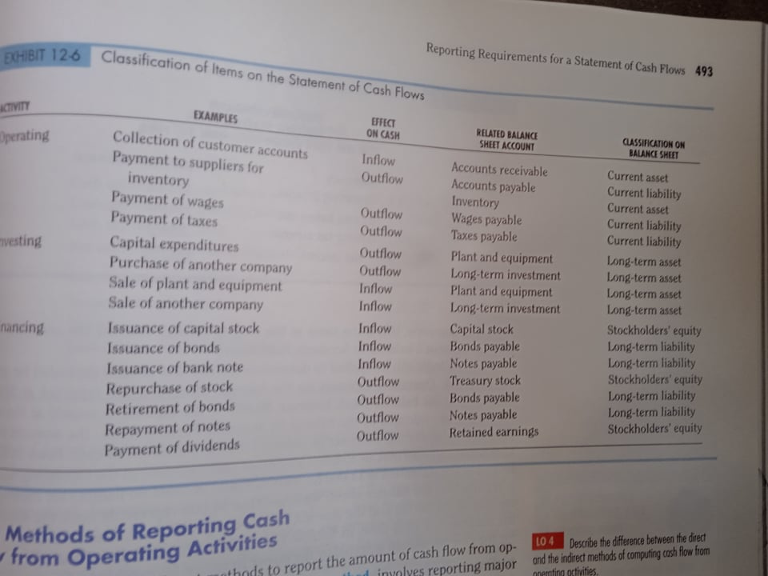

Preparing the Statement of Cash Flows: Direct Method
Determination of Cash flow from Operating activities under Direct Method:
Particulars | Amount
- Cash flow from sales and collection from Debtors/customers | Inflow
- Cash Paid to creditors ( supplier for purchase of merchandise) | Outflow
- Cash paid to employee and overhead expenses | Outflow
- Interest Paid | Outflow
- Tax Paid | Outflow
- Other receipts (Interest and dividend | Inflow
Cash flow from Operating activities ( A+B+C+D+E+F)

To report cash flow from operating activities under the direct method, we look at each of the items on the income statement and determine how much cash each of these activities either generated or used.
- Cash flow from sales and collection from Debtors/customers: Amount of sales includes credit as well as cash sales. There might be bad debt , discount allowed etc which indicates that the sales revenue recorded in income statement is not the actual amount of cash collected from the customer. Therefore some adjustment is needed to find out cash collection from customer which are summarized in the table below:
Particulars | Amount
Net sales ( cash sales+ credit sales – return) | Xxx
Discount allowed | (xxx)
Bad debt written off | (xxx)
Bad debt recovered | Xxx
Decrease in A/c receivable/debtors/bills receivable | Xxx
Increase in A/c receivable/debtors/bills receivable | (xxx)
Cash collection from customers

- Cash Paid to creditors (supplier for purchase of merchandise): As sales include both cash and credit sales similarly goods are also purchased on cash and credit. There might be discount received, therefore the cost of goods sold shown on the income statement does not reflect the actual amount paid for purchases. Therefore some adjustment are needed to find out the amount paid to suppliers which are summarized in the table below:
Particulars | Amount
COGS(B.I + Purchases + direct expenses – E.I) | (xxxx)
Discount Received | Xxx
Increase in Inventory | (xxx)
Decrease in Inventory | Xxx
Increase in account payable | Xxx
Decrease in account payable | (xxx)
Payment to Suppliers | (XXXX)
- Cash paid to employees and other operating expenses: As income statement is prepared under accrual basis the amount of operating expense shown does not reflect the cash paid for the same therefore accruals and deferral must be adjusted.
Particulars | Amount
Operating expenses( excluding depreciation and amortization) | (xxx)
Increase in Prepaid expenses | (xxx)
Decrease in prepaid expenses | Xxx
Increase in Accrued expense | Xxx
Decrease in Accrued expense | (xxx)
Cash paid to employees and other operating expenses | (xxx)
- Interest Paid: As the Interest expense shown on the income statement is not the actual amount of cash outflow for interest, it needs to be adjusted.
Particulars | Amount
Interest expense (as per income statement)
Increase in accrued interest
Decrease in accrued interest
Total
- Tax paid: Actual cash outflow for tax expense is calculated as follows:
Particulars | Amount
Tax expense | (xxx)
Decrease in prepaid tax | Xxx
Increase in prepaid tax | (xxx)
Increase in tax payable or provision for tax | Xxx
Decrease in tax payable or provision for tax | (XXX)
Amount of tax paid | (XXX)
- Other receipts: In operation of business activities there might be some other receipt apart from sales. It is calculated as follows:
Particulars | Amount
Interest Income
Commission income
Dividend received
Rent income
Increase in accrued income
Decrease in accrued income
Increase in advance income
Decrease in advance income
Other Receipts
Q) 2019 spring :

Indirect Method

Journal entries related with Assets purchase and sales:
- Entry for purchase of assets:
Assets a/c Dr
To Cash a/c.
- Entry for Depreciation:
Depreciation a/c Dr
To Accumulated depreciation- Asset
- Entry for Sale: ( On Loss)
Cash a/c Dr
Loss on sale Dr
Accumulated Depreciation(sold part) Dr
To Assets a/c
Ledger effect of the above transactions: Please note opening and closing balances of accounts are available on the balance sheet.
Assets account
Date | Particulars | PR | Amount | Date | Particulars | PR | Amount
 | To balance b/d |  | 600000 |  | By cash (sold part){b/f} |  | 25000
 | To cash (new purchase){b/f} |  | 195000 |  | By loss |  | 5000
 |  |  |  |  | By acc depreciation |  | 15000
 |  |  |  |  | By balance c/d |  | 750000
Accumulated depreciation
Date | Particulars | PR | Amount | Date | Particulars | PR | Amount
 | To Asset a/c (b/f) |  | Xxxx |  | By balance b/d |  | 250000
 |  |  |  |  | By depreciation (current) |  | 75000
 | To balance c/d |  | 310000

Q) Rani traders just completed another successful year, as indicated by the following income statement for 2019:
Particulars | Amount
Sales revenue | 12,50,000
Less: COGS | 7,00,000
Gross Margin | 5,50,000
Less: Operating expenses | 1,50,000
Income before interest and tax | 4,00,000
Interest expense | 25,000
Net income before tax | 3,75,000
Income tax expense | 1,50,000
Net Income | 2,25,000
Comparative Balance sheet
Particulars | 2019(Rs) | 2018(Rs)
Assets
Cash | 52,000 | 90,000
Account receivable | 1,80,000 | 1,30,000
Inventory | 2,30,000 | 2,00,000
Prepaid insurance | 15,000 | 25,000
Total current assets | 4,77,000 | 4,45,000
Land | 7,50,000 | 6,00,000
Plant and equipment | 7,00,000 | 5,00,000
Accumulated depreciation- plant | 2,50,000 | 2,00,000
Total long term Assets | 12,00,000 | 9,00,000
Total Assets | 16,77,000 | 13,45,000
Accounts Payable | 1,30,000 | 1,48,000
Salary Payable | 68,000 | 63,000
Income tax payable | 90,000 | 1,10,000
Total current liabilities | 2,88,000 | 3,21,000
Long term bank loan | 3,50,000 | 3,00,000
Common stock | 5,50,000 | 4,00,000
Retained Earnings | 4,89,000 | 3,24,000
Total stockholder’s equity | 10,39,000 | 7,24,000
Total liabilities and stockholder’s Equity | 16,77,000 | 13,45,000
Other info are as follows:
- Dividend of Rs 60,000 were declared and paid during the year.
- Operating expense include Rs 50,000 of depreciation.
- Land and plant and equipment were acquired for cash and additional stock was issued for cash. Cash was also received from additional bank loan.
- The president has asked you some questions about the year’s result. She is very impressed with the profit margin of 18%. She is worried by the decline in the company’s cash balance during the year. One of the conditions of the existing bank loan is that the company maintains a minimum cash balance of Rs 50,000.
Required: prepare cash flow statement using direct method. On the basis of your statement, draft a brief memo to the president to explain why cash decreased during such a profitable year. Include in your explanation any recommendation for improving the company’s cash flow in future years.
Q) 2021 spring:

Global trading concern, Pokhara is in the process of preparing its cash flows for the year ended Dec 31st , 2020. An income statement for the year and comparative balance sheets are as follows:
Particulars | Amount
Sales Revenue | 5,50,000
Less: COGS | 3,50,000
Gross Margin | 2,00,000
Less: Operating expenses
General and administrative expense | 55,000
Depreciation expenses | 75,000
Loss on sale of plant | 5,000
Total expense and losses | 1,35,000
Income before interest and taxes | 65,000
Less: Interest expense | 15,000
Income before taxes | 50,000
Less: Tax expenses | 17,000
Net income after tax | 33,000
Comparative Balance sheets
Assets | 31st dec 2020 | 31st Dec 2019 | Liabilities & Stockholder’s equity | 31st Dec 2020 | 31st Dec 2019
Cash | 31,000 | 40,000 | Accounts payable | 1,55,000 | 1,48,000
Accounts Receivable | 90,000 | 75,000 | Other accrued liabilities | 32,000 | 26,000
Inventory | 80,000 | 95,000 | Tax payable | 8,000 | 10,000
Prepaid expense | 12,000 | 16,000 | Long term bank loan | 1,00,000 | 1,30,000
Land | 2,50,000 | 1,70,000 | Common stock | 3,50,000 | 2,00,000
Plant & equipment | 7,50,000 | 6,00,000 | Retained earnings | 2,58,000 | 2,32,000
Accumulated depreciation | (3,10,000) | (2,50,000)
Total | 903000 | 746000 |  | 903000 | 746000
- Plant assets were sold during the year for Rs 25,000 in cash. The original cost of the assets sold was Rs 45,000, and their book value was Rs 30,000.
- Portion of bank loan was repaid.
- Additional stock was issued for cash.
- Land was purchased for cash.
Required: Cash flow statement and comment on the cash flow.

Q) Evaluate the following statement: Whether a company uses the direct or indirect method to report cash flows from operations is irrelevant because the amount of cash flow from operating activities is the same regardless of which method is used.
Answer: The amount of cash flow is same regardless of which method is used is a true statement as both direct and indirect method are simply different computational approaches to arrive at cash generated from operations. The Financial Accounting Standard Board has expressed a strong preference for the direct method but allows companies to use the indirect method. If a company uses indirect method, it must separately disclose two important payments: income tax paid and interest paid. Advocates of direct method believe it to be more user friendly and someone without a technical background in accounting can easily tell where cash came from and where it went during the period, whereas advocates of indirect method argue that direct method reveals too much about their business.
Q) A trading concern had the following financial statements prepared as of December 31st 2017:
Income Statement for the period ended 31st December 2017
Particulars | Amount
Sales Revenue | 89,000
Less: COGS | 57,000
Gross Margin | 32,000
Depreciation | 6,500
Advertising expense | 3,200
Salaries expenses | 12,000
Total operating expenses | 21,700
Operating Income | 10,300
Loss on sale of land | 2,500
Income before tax | 7,800
Income tax | 2,600
Net Income | 5,200

Balance sheet as of December 31st 2017
Particulars | 2017 | 2016
Cash | 12,000 | 9,500
Account receivable | 22,000 | 18,400
Inventory | 25,400 | 20,500
Prepaid Advertisement | 10,000 | 8,600
Total Current Assets | 69,400 | 57,000
Land | 1,20,000 | 80,000
Equipment | 1,90,000 | 1,30,000
Accumulated Depreciation | (70,000) | (63,500)
Total Long Term Assets | 2,40,000 | 1,46,500
Total Assets | 3,09,400 | 2,03,500
Account payable | 15,300 | 12,100
Salaries payable | 14,000 | 16,400
Income tax payable | 1,200 | 700
Total current liabilities | 30,500 | 29,200
Notes Payable | 70,000
Capital Stock | 1,30,000 | 1,00,000
Retained earnings | 78,900 | 74,300
Total Stockholders’ Equity | 2,08,900 | 1,74,300
Total Liabilities and Stockholders’ Equity | 3,09,400 | 2,03,500
Additional Information:
- Land was purchased by issuing notes during the year.
- A piece of land was sold during the year for Rs 27,500.
- Capital stock was issued for cash.
You are required to prepare statement of cash flows and also calculate cash from operating activity under indirect method.
Q) TS and VS company has prepared income statement and balance sheet on 31st December, 2017 as follows:
Income Statement for the period ended 31st December 2017
Particulars | Amount
Sales Revenue | 89,000
Less: COGS | 57,000
Gross Margin | 32,000
Depreciation | 6,500
Advertising expense | 3,200
Salaries expenses | 12,000
Total operating expenses | 21,700
Operating Income | 10,300
Loss on sale of land | 2,500
Income before tax | 7,800
Income tax | 2,600
Net Income | 5,200
Balance sheet as of December 31st 2017
Particulars | 2017 | 2016
Cash | 12,000 | 9,500
Account receivable | 22,000 | 18,400
Inventory | 25,400 | 20,500
Prepaid Advertisement | 10,000 | 8,600
Total Current Assets | 69,400 | 57,000
Land | 1,20,000 | 80,000
Equipment | 1,90,000 | 1,30,000
Accumulated Depreciation | (70,000) | (63,500)
Total Long Term Assets | 2,40,000 | 1,46,500
Total Assets | 3,09,400 | 2,03,500
Account payable | 15,300 | 12,100
Salaries payable | 14,000 | 16,400
Income tax payable | 1,200 | 700
Total current liabilities | 30,500 | 29,200
Capital Stock | 2,00,000 | 1,00,000
Retained earnings | 78,900 | 74,300
Total Stockholders’ Equity | 2,08,900 | 1,74,300
Total Liabilities and Stockholders’ Equity | 3,09,400 | 2,03,500
Additional Information:
- Land was acquired during the year Rs 70,000.
- An unimproved parcel of land was sold during the year for Rs 27,500
- A specialized piece of equipment costing Rs 60,000 was acquired in exchange for capital stock in the company.
- In addition to the capital stock issued in exchange for specialized equipment, some stocks were also sold for cash.
You are required to prepare statement of cash flows and also calculate cash from operating activity under indirect method and also comment on the cash position.

